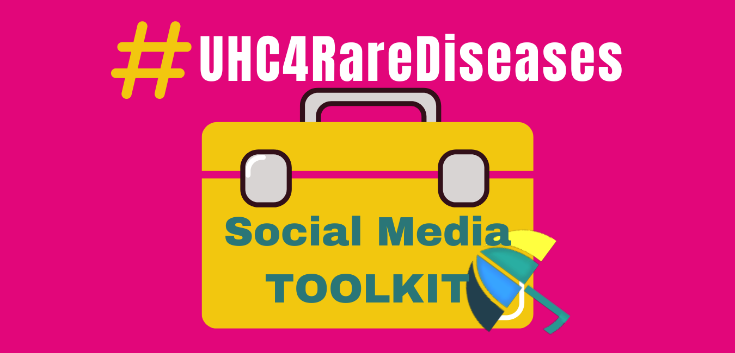

CAMPAIGN HASHTAG

#UHC4RareDiseases

- Add this hashtag to all your posts.
- Using #UHC4RareDiseases will help us know how many people and organisations have taken part in the campaign on social media.
- Tag EURORDIS (@eurordis) and RDI (@rarediseasesint)

OTHER RECOMMENDED HASHTAGS:

- #RareDiseaseDay
- #HealthForAll
- #UHC2030

CLICK TO DOWNLOAD SOCIAL MEDIA IMAGES

- GIFS (Animated images)
- https://www.rarediseasesinternational.org/wp-content/uploads/2020/10/PINK.gif
- https://www.rarediseasesinternational.org/wp-content/uploads/2020/10/Purple.gif
- https://www.rarediseasesinternational.org/wp-content/uploads/2020/10/Blue.gif
- https://www.rarediseasesinternational.org/wp-content/uploads/2020/10/Cobertura-sanitaria-universal-sin-excepciones.gif (Spanish)
- https://www.rarediseasesinternational.org/wp-content/uploads/2020/10/Azul.gif Spanish)

- Images
https://www.rarediseasesinternational.org/wp-content/uploads/2020/10/UHC4rarediseases-7.png  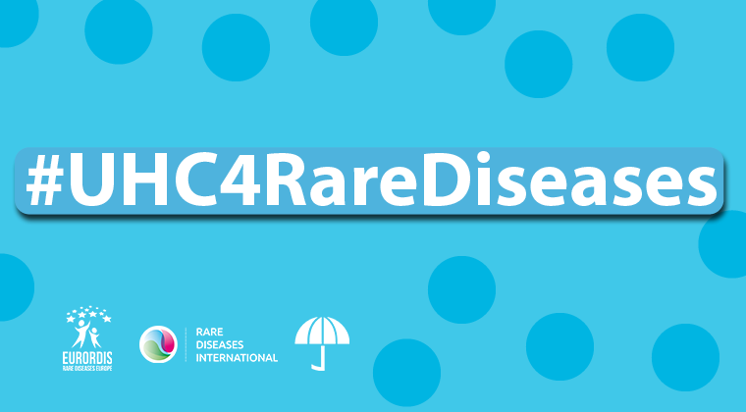 | https://www.rarediseasesinternational.org/wp-content/uploads/2020/10/Is-a-human-right.png  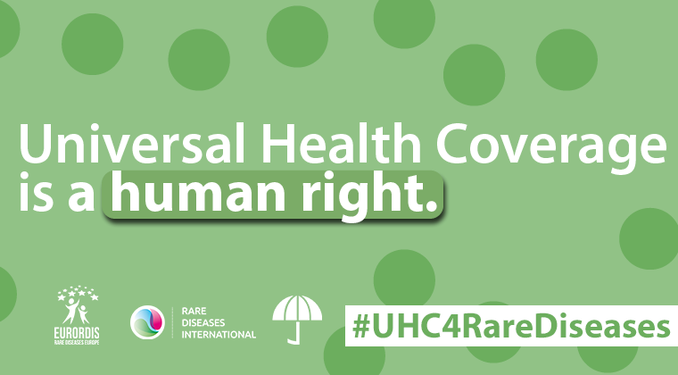

TWITTER & FACEBOOK POSTS

Here are some post suggestions. Change the words and translate posts so they have the most impact for your community.

- Post 1:

Universal Health Coverage is only truly universal if it also addresses the needs of people living with a rare disease. Advocate for #UHC4RareDiseases

Use the toolkit to spread the word! #HealthForAll #UHC2030
https://www.rarediseasesinternational.org/uhc4rarediseases/

- Post 2:

Universal Health Coverage ensures all people can access quality health services without financial hardship.

People living with a #RareDisease have specific medical & social needs. They must be fully included in #UHC programmes.

Leave no one behind. Demand #UHC4RareDiseases !

- Post 3:

Over 300 million people around the world live with a #RareDisease. UHC is for all. UHC is for the 300 million. #UHC4RareDiseases #HealthforAll

- Post 4:

#RareDiseaseDay calls for equity. #UHC must promote the health and social rights of people living with a rare disease to enable everyone to participate in society. #HealthForAll and equity for #RareDiseases.

Demand #UHC4RareDiseases! Use the toolkit to spread the word!
https://www.rarediseasesinternational.org/uhc4rarediseases/

- Post 5 (for Facebook):

Universal Health Coverage ensures all people, everywhere, can access the quality essential health services they need without being exposed to financial hardship.

With over 300 million people worldwide living with a rare disease, addressing the needs of the rare disease community is an important step towards UHC for every country.

#UHC4RareDiseases #HealthForAll

LinkedIn Post

EURORDIS and Rare Diseases International (RDI) are launching the UHC for Rare Diseases Campaign (#UHC4RareDiseases). The Campaign provides a toolkit with essential tools to enable rare disease organisations to advocate for Universal Health Coverage (UHC) programmes inclusive of rare diseases.
Find the #UHC4RareDiseases toolkit:
https://www.rarediseasesinternational.org/uhc4rarediseases/

- Send the template letter advocating for UHC and rare disease plans to your government representative
- Share the factsheet with policy recommendations to help implement UHC policies that address rare diseases
- Use social media posts and images to spread the word online

The campaign aims to raise awareness amongst policy makers and the public of the fact that UHC cannot be truly universal unless it addresses the needs of people living with a rare disease.

Over 300 million around the world live with a rare disease. UHC is for all. UHC if for the 300 million. #UHC4RareDisease #HealthforAll

